LED chaser circuit using Aurdino UNO

Circuit Diagram:

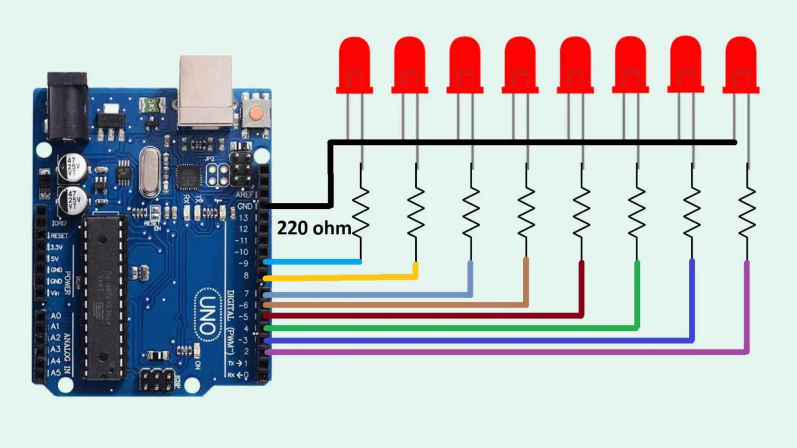

**Components needed for this project**

* Arduino UNO-1
* LEDs-8
* Resistor 220 ohm - 8
* Jumper wires
* Breadboard

Aurdino code for LED chaser circuit:

int led[]={2,3,4,5,6,7,8,9};

void setup()

{

for(int i=0;i<8;i=i+1)

{

pinMode(led[i],OUTPUT);

}

}

void loop()

{

for(int i=0;i<8;i=i+1)

{

digitalWrite(led[i],HIGH);

delay(500);

}

for(int i=8;i>=0;i=i-1)

{

digitalWrite(led[i],LOW);

delay(500);

}

}